ICT378 Final Assignment Checklist
Table of Contents
ICT378 Final Assignment Checklist 1
TLDR: 1
Steve (Autopsy) 3
Steve (Magnet Axiom) 4
John (Autopsy) 5
John (Magnet) 6
Jane (Autopsy) 6
Jane (Magnet) 7

TLDR:
30 Oct 2025 12.07 AM – Vincent
Below contains all the evidence tagged from Autopsy and Magnet. Enjoy :)
Things we must include in our investigation for all three suspects (In Autopsy)
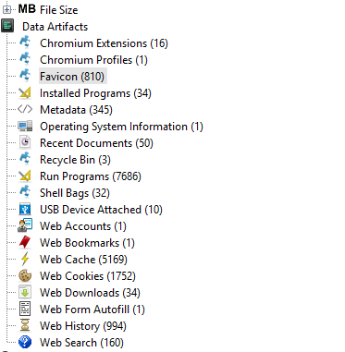
I’d mainly focused on:
- Installed programs to see what software were installed on suspect’s system e.g. to show proof that there’s disk cleaner such as CC cleaner or encryption tools TrueCrypt installed
- Operating system information to show suspect’s OS version, build, hostname, time zone, user account
- Recent documents to see what the recently accessed files are, to show user interactions and their behavior when using the computer,
- Recycle bin pretty straightforward, to find deleted files relevant to scenario
- Shell bags to show user folder browsing behavior in file explorer
- Web downloads to confirm the files they have downloaded
- Web history and Web search to show the intention of the suspect, what are they trying to do, we can use it to support motive or intent

For each evidence, include the table of findings according to sample report so that can score more points. Include MD5 and SHA1 hash also

Steve (Autopsy)
Filename | Path | Contents in the file
secret | /img_Narcos-1.001/vol_vol7/Users/Steve/Documents/secret | Secret file to be decrypted
price-meth-bust-4.jpg | /img_Narcos-1.001/vol_vol7/Users/Steve/Pictures/price-meth-bust-4.jpg | Image of drugs and cash
620x349.jpg | /img_Narcos-1.001/vol_vol7/Users/Steve/Pictures/620x349.jpg | Picture of crystal meth
Method run.jpg | /img_Narcos-1.001/vol_vol7/Users/Steve/Documents/Misc/Method run.jpg | Seemed like Picture of drug transport route
airport crystals.jpg | /img_Narcos-1.001/vol_vol7/Users/Steve/Documents/Misc/airport crystals.jpg | Picture from airport to Eastbourne,
eight_col_patches_crp.jpg | /img_Narcos-1.001/vol_vol7/Users/Steve/Pictures/eight_col_patches_crp.jpg | Picture of Mongrel Mob fatherland, seemed like gang affiliation
ccsetup552.exe | /img_Narcos-1.001/vol_vol7/Users/Steve/Downloads/ccsetup552.exe | CC cleaner executable file
Image Steganography 1.5.2 Setup.exe | /img_Narcos-1.001/vol_vol7/Users/Steve/Downloads/Image Steganography 1.5.2 Setup.exe | Image steganography executable file
TrueCrypt Setup 7.1a.exe | /img_Narcos-1.001/vol_vol7/Users/Steve/Downloads/TrueCrypt Setup 7.1a.exe | TrueCrypt executable file
dropoff.jpg | /img_Narcos-1.001/vol_vol7/Users/Steve/Documents/Misc/dropoff.jpg | Drop off point of east bourne library
flightbookings.PNG | /img_Narcos-1.001/vol_vol7/Users/Steve/Documents/Misc/flightbookings.PNG | Flight ticket from Brisbane AUS to Wellington NZ
BNE.png | /img_Narcos-1.001/vol_vol7/Users/Steve/Downloads/Misc/BNE.png | Steganography image due to its large size (4mb)
000006.log | /img_Narcos-1.001/vol_vol7/Users/Steve/AppData/Roaming/Discord/Local Storage/leveldb/000006.log | Discord logs chat with draft messages

Steve (Magnet Axiom)
At best I can get Discord messages that are organized nicely in a section
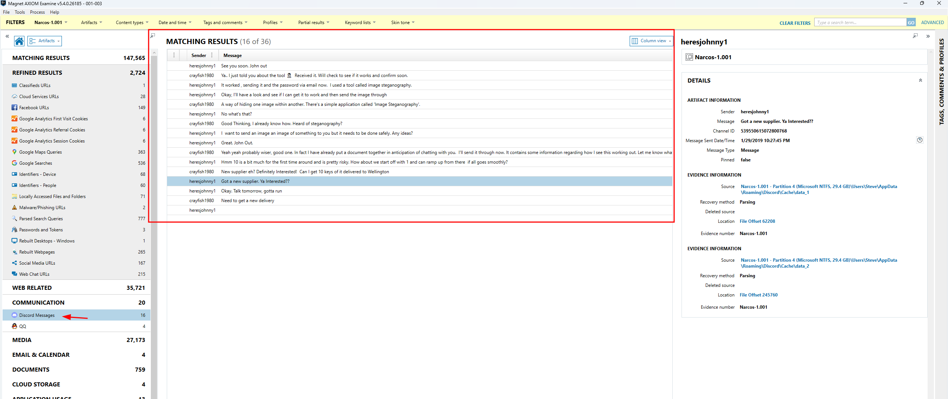
I tagged this interesting file from the Microsoft One Note cache data, since I can’t crack the one drive I found this thing pretty interesting, seemed like Steve wrote on his one note for the steganography password
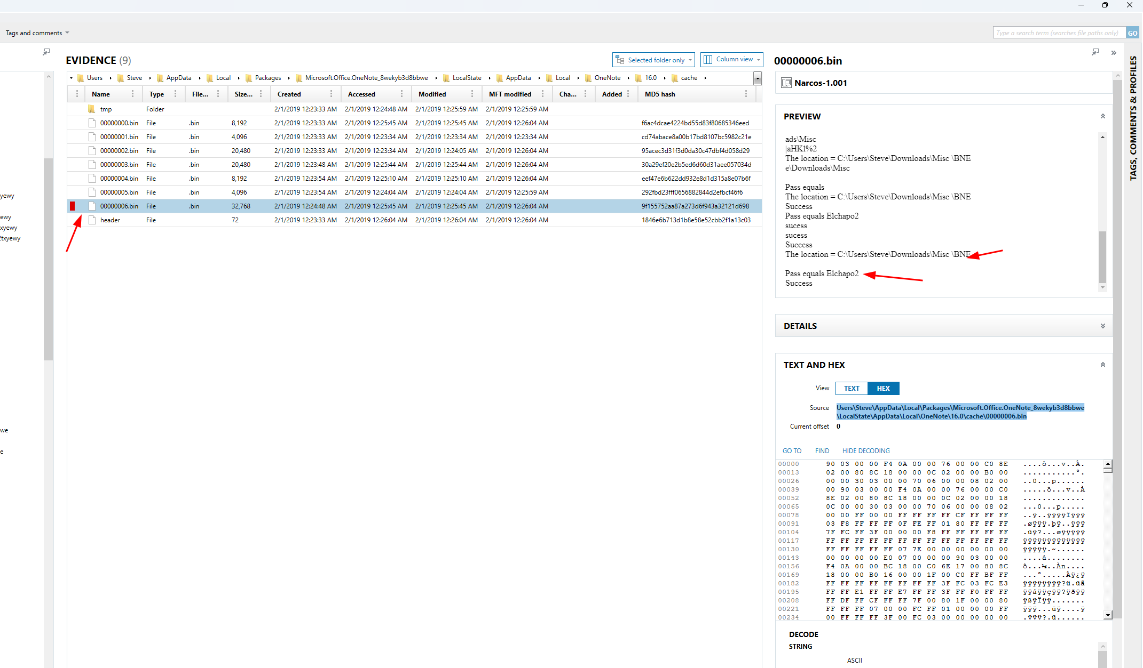

I am pretty sure we can do the same for other suspects. Provided we know they got use OneDrive in their system based on recently accessed applications etc.

John (Autopsy)
Filename | Path | Contents in the file
shipping.PNG | /img_Narcos-2.001/vol_vol7/Users/JohnF/Documents/Business/shipping.PNG | DHL Shipping Package
Contact_Card.zip | /img_Narcos-2.001/vol_vol7/Users/JohnF/Downloads/Contact_Card.zip | Contact Card sent by Jane
Attachments-Important, crucial to our method.zip | /img_Narcos-2.001/vol_vol7/Users/JohnF/Downloads/Attachments-Important, crucial to our method.zip | Zip file sent by steve containing secret file to be decrypted
Clients.ods | /img_Narcos-2.001/vol_vol7/Users/JohnF/Documents/Business/clients.ods | Excel sheet, seemed like a list of Steve’s Client for drugs
Janes Kids.jpg | /img_Narcos-2.001/vol_vol7/Users/JohnF/AppData/Local/Temp/vmware-JohnF/VMwareDnD/2cce6695/Janes Kids.jpg | Picture of Jane’s Kid
Memes | /img_Narcos-2.001/vol_vol7/Users/JohnF/Documents/Memes | Bunch of drug memes
1540752698-brisbane.jpg | /img_Narcos-2.001/vol_vol7/Users/JohnF/Pictures/1540752698-brisbane.jpg | Original image before steganography
BNE.png | /img_Narcos-2.001/vol_vol7/Users/JohnF/Pictures/BNE.png | Steganography image
Steve K.PNG | /img_Narcos-2.001/vol_vol7/Users/JohnF/Documents/Business/Steve K.PNG | Flight ticket
Image Steganography 1.5.2 Setup.exe | /img_Narcos-2.001/vol_vol7/Users/JohnF/Downloads/Image Steganography 1.5.2 Setup.exe | Image steganography executable file
TrueCrypt Setup 7.1a.exe | /img_Narcos-2.001/vol_vol7/Users/JohnF/Downloads/TrueCrypt Setup 7.1a.exe | TrueCrypt executable file
000007.ldb | /img_Narcos-2.001/vol_vol7/Users/JohnF/AppData/Roaming/Discord/Local Storage/leveldb/000007.ldb | Discord logs
000013.log | /img_Narcos-2.001/vol_vol7/Users/JohnF/AppData/Roaming/Discord/Local Storage/leveldb/000013.log | Discord logs

John (Magnet)
Nothing of interest, Magnet didn’t parse any discord messages this time around

Jane (Autopsy)
Filename | Path | Contents in the file
afp.png | /img_Narcos-3.001/vol_vol7/Users/JaneE/Pictures/afp.png | Picture of Australian Federal police badge
background.jpg | /img_Narcos-3.001/vol_vol7/Users/JaneE/Pictures/background.jpg | Background image of AFP
000003.log | /img_Narcos-3.001/vol_vol7/Users/JaneE/AppData/Roaming/Discord/Local Storage/leveldb/000003.log | Discord logs
Contact Card.zip | /img_Narcos-3.001/vol_vol7/Users/JaneE/Downloads/Contact Card.zip | Contact Card Zip, suspected malware Jane use
Quasar v1.3.0.0 | /img_Narcos-3.001/vol_vol7/Users/JaneE/Downloads/Quasar v1.3.0.0 | Remote access trojan jane downloaded and inside contain a folder targeting John, she’s spying on him using malware
01-30-2019.html | /img_Narcos-3.001/vol_vol7/Users/JaneE/Downloads/Quasar v1.3.0.0/Clients/JohnF@JOHNFLAPTOP1_4DD90B0/Logs/01-30-2019.html | Logs collected by Jane from Quasar
01-31-2019.html | /img_Narcos-3.001/vol_vol7/Users/JaneE/Downloads/Quasar v1.3.0.0/Clients/JohnF@JOHNFLAPTOP1_4DD90B0/Logs/01-31-2019.html | Logs collected by Jane from Quasar
02-01-2019.html | /img_Narcos-3.001/vol_vol7/Users/JaneE/Downloads/Quasar v1.3.0.0/Clients/JohnF@JOHNFLAPTOP1_4DD90B0/Logs/02-01-2019.html | Logs collected by Jane from Quasar
02-02-2019.html | /img_Narcos-3.001/vol_vol7/Users/JaneE/Downloads/Quasar v1.3.0.0/Clients/JohnF@JOHNFLAPTOP1_4DD90B0/Logs/02-02-2019.html | Logs collected by Jane from Quasar
crys1.jpg | /img_Narcos-3.001/vol_vol7/Users/JaneE/Pictures/crys1.jpg | Picture of crystal meth
crys2.jpg | /img_Narcos-3.001/vol_vol7/Users/JaneE/Pictures/crys2.jpg | Picture of crystal meth
crys3.jpg | /img_Narcos-3.001/vol_vol7/Users/JaneE/Pictures/crys3.jpg | Picture of crystal meth
course-undercover-survival.pdf | /img_Narcos-3.001/vol_vol7/Users/JaneE/Documents/course-undercover-survival.pdf | PDF on how to survive as undercover

Jane (Magnet)
Discord conversations
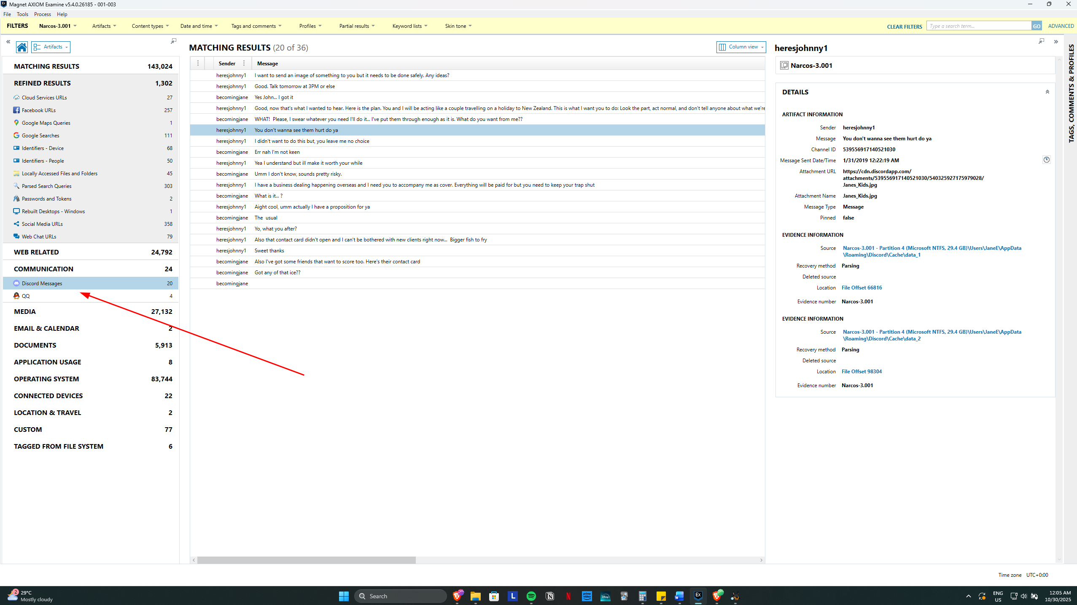
Was able to go through caches of OneNote and found Diary of Jane
